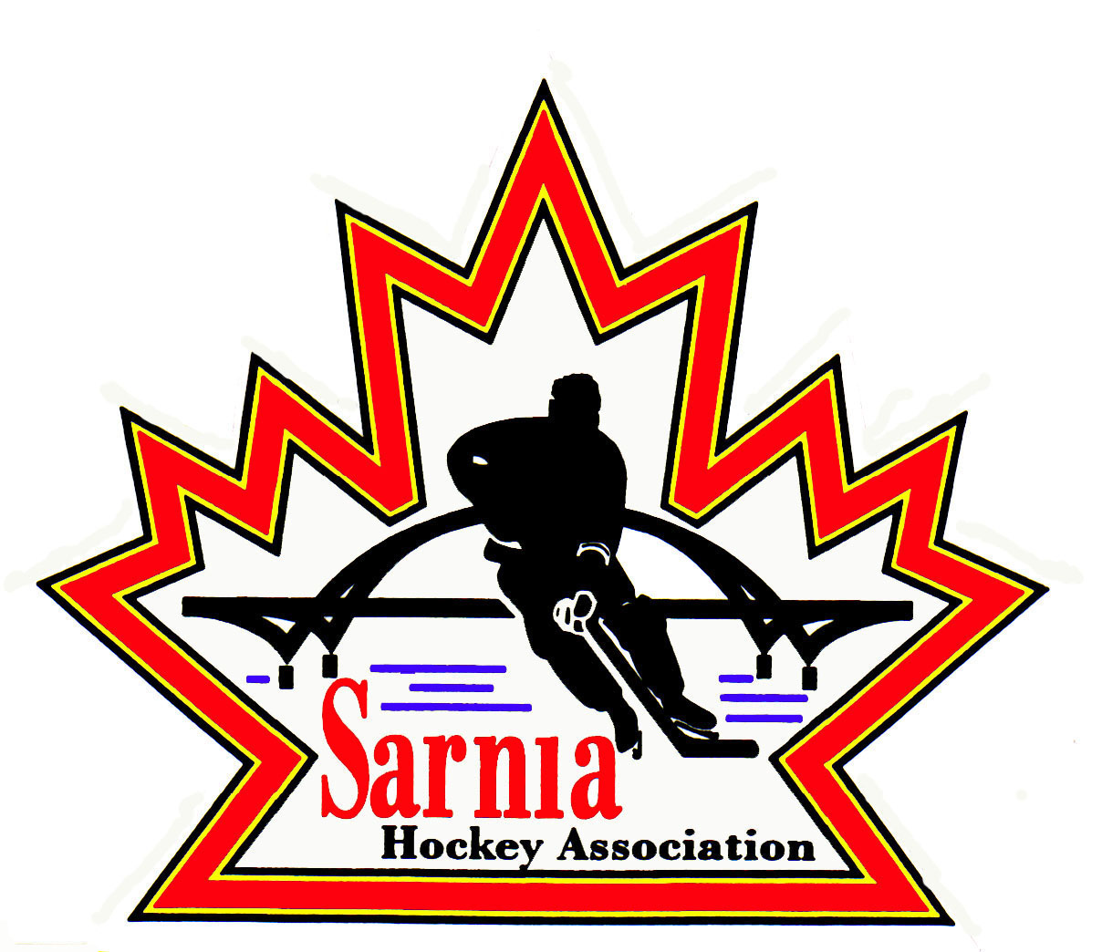

Sarnia Hockey Association

Minutes | Date: NOVEMBER 20, 2024 | time 7:00 pm

Meeting called by | Paul Walsh, President
Type of meeting | Regular
Secretary | Kelly Lane, Recording Secretary

Welcome | Paul Walsh, President, and meeting Chair welcomed everyone and called the meeting to order at 7:08 pm.

ATTENDANCE | Jacquie Beasley, Jerry Bernardo, Emily Brown, Brendan Douglass, Chuck Ewart, Kelly Lane, Cris LaPointe, Don McGugan, John Mellor, Kyle Mellor, David Penner, Wayne Scarrow, Jason Teather, Tim Turner, Paul Walsh  Regrets: Heather Amaral, Andrew Beasley, Alister Brown, Darren Chevalier, Ian Dunn, Pat Forbes, Dan Hunt, Linda Lauzon, Bonny Marcy, Jeffrey Needham, Ted Pendle, Lesley Smith-Taylor, Kevin Taylor, Jason Teather

ACCEPTANCE OF MINUTES | MOTION #241120-001  “That the Minutes from November 5, 2024, be accepted as presented.” (E. Brown/Bernardo)  Carried with one amendment  Under Bills change amount to $450 to 6X4 Goaltending.

TREASURER’S REPORT | - Still some outstanding teams loans. Two teams were given extensions. Treasurer will send notes out to those teams that still owe. Some made payments tonight.  - Rep Assessment fees – final payment is now due. Some have not made payments. Rep Directors did send out note to teams to complete the payments. All fees due by Dec 1.  - Those with outstanding payments should have received notices from Sportle as well re payments.  - Treasurer is worried that some have not paid any money to date.  - May be some confusion re how to etransfer.  - Just an FYI that due to pending mail strike, fees for Silver Stick could be impacted. Silver Stick Director is aware and contacting teams that still owe tournament fees.

BILLS TO BE PAID | MOTION #241120-002  “That the bills be paid as presented.” (E. Brown/K. Mellor)  Carried  - Cousi Committee received 2 Pat Stapleton jerseys which they want to use to raise money. They have also spoken with the Legionnaires Junior B Team and will use their fundraising structure to launch this jersey auction on January 9. Legionnaires are happy with this idea and want minor hockey players to attend for free if they show up with jerseys. They will offer discounted tickets for parents. They want to have a Cousi display at the arena and keep the jersey up until May 31. There will be a cheque presentation with the Legionnaires and Cousi Committee. We would post on our social media and connect with Strathroy Minor Hockey to attend as well. Money would go to Sarnia Community Foundation who would then cut the cheque to Sarnia Hockey.
  Recipient | Expense | Amount
  Alister Brown  First Shift  6x4 Goaltending  Dark Horse Goaltending | Lock replacement  Refreshments  Shared ice practices U15 and U13 Rec  Rep Coaching Session U9 Tier 2  PD Clinic Nov 15  PD Clinic Nov 15 | $ 235.04  $ 144.75  $1,500.00  $300.00

REP VICE PRESIDENT | - AA Director is attending Rep Council Meeting occurring this evening. They will be discussing the seeded team split and what the split will be. They had proposed split based on last year’s standings. This weekend is final weekend of seeded part of schedule. They will be testing whether actual standings match what the proposed split would be. There may be some difference in proposed split.

SILVER STICK | - Schedule is posted online. Still have some outstanding payments. Most teams have rosters and travel permits. A lot of buzz from the teams and they are excited to attend.  - Team from Winnipeg and a team from Ontario California for AAA tournament in December at U18 level.  - AAA is an invite tournament.  - Volunteer situation is good.  - Referees are set up.

WINTER CLASSIC TOURNAMENT | - A U11 and a U15 team from Mooretown have entered the tournament.  - Expect schedule to be built in first part of December.  - Some new volunteers but can always use more. Tournament Director’s work schedule may impede his time so may need some Directors to help out.

REC VICE CHAIR | - Sarnia Hockey Day went well on November 17th at the Sarnia Sting Game. The Sponsors were happy with the event. Cousi cheque presentation occurred, and all of the intermission events and pregame skate went well. Good feedback from the Sting organization as well as from the Cousi Committee. There was a good turnout of Sarnia players in their jerseys. There was a good turnout for Foundations aged players as we had 60 kids out on the ice and they were very excited.

REP DIRECTOR | - Two BB teams won Nazem Kadri Tournament for their age division.  - B teams seed on December 5.  - U13 Black won Rec division.

CLINIC DIRECTOR | - Working on scheduling a Body Checking refresher for U14’s. It is an Alliance policy.  - Our U14 A had an injury in practice due to a body check. Refresher will remind players about their positioning.  - It is for players on the A team and those on B interested in taking the refresher.

PHOTOGRAPHY | - Photography will be completed after Christmas due to Metcalfe Photography scheduling.  - Working on schedule in the new year.

NEW BUSINESS | NEXT MEETING:  - Next meeting is Tuesday, December 3, 2024, at 7:00 pm at Clearwater Arena Lower Hall.  - We will adjourn to Boston Pizza for year-end celebration following a short meeting to recognize effort of our Board volunteers.

adjournment | MOTION #241120-003  “That the meeting be adjourned.” (McGugan/Bernardo)  Carried

Paul Walsh Kelly Lane
President Secretary

